Day – 5
Introduction of Course
Prerequisites – Day 1 to Day 4
Learning Path MindMap (Topics of Discussion today)
AWS Essential services MindMap?
AWS Region with Real Time scenarios
Availability Zone in AWS with Real Time scenarios
How VPC helps with Real Time scenarios
How Ec2 Become a web Server?
PROJECT 01: HOST YOUR FIRST Web Application on EC2?
S3 Real Time Use cases
PROJECT 02: HOST A STATIC WEBSITE ON S3 BUCKET
IAM Roles and Policies with Real Time scenarios
PROJECT 03: HOW TO ACCESS A S3 BUCKET FROM AN EC2 INSTANCE?

Introduction of Course
We are going to discuss essential AWS services to know as a DevOps Engineer. With 3 to 4 topics with Theory + Demo

Learning Path MindMap (Topics of Discussion today)
Learning Path

Monitoring
Security
Infrastructure
CI / CD
Essential Services

Apart from this tools, we will going to see project implementation with each tool.

AWS Essential services MindMap?
Before we get into DevOps, let’s discuss some essential AWS services which are required.
Essential Services are kind of building blocks, i.e., without knowing these services we can’t say that you are a DevOps Engineer / Cloud Engineer.

Building Blocks
Essential Services

IAM Roles & Policies
S3
Region & Availability Zone (AZ)
EC2
VPC

If you don’t know these topics, this session is for learning those.
Let’s discuss each topic one-by-one.
AWS Region with Real Time scenarios

Region is something which is actual geographic locations where your data centers are located.
Datacenter is a kind of building where the entire infrastructures are present. In sense, you know you are creating EC2 instances and you are trying to access it, whatever you think you need to access it remotely is present somewhere i.e., infrastructure is lying somewhere and you are just taking a part of it like t2.micro, where remotely you will get the allocation of particular resources to the instance like memory, cpu, OS image.

How we consider a Region?

Whatever reason will to be considered, it have atleast one Availability Zone and upto 6 AZ’s.
Region can also be a state like Ohio, Oregon, and N.Virgina
Region can also be cities like Mumbai, London.
Region can also be countries like Canada, Singapore.

How to Region in AWS?
On the AWS console, top right beside of profile name.
US East (N.Virginia), US East (Ohio), US West (N.California), US West (Oregon)
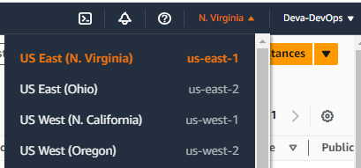

Availability Zone in AWS with Real-time scenarios

What is Availability Zone? In AWS
Availability Zone is something like while talked about region, each region has multiple isolated locations and those are called Availability Zones (AZ).
Your actual Data-Center resides in Availability Zone (AZ).
Availability zones inside a Region are at a distance of 100 Km to 60 Miles from each other.
These are the things which allow AWS to achieve Redundancy.
If you are achieving redundancy means you can host your application in many different regions because you can run the same application in multiple regions.
us-east-1
App
us-west-1

Suppose you have hosted an application on us-east-1 and us-west-1 regions and if us-east-1 region goes down, you can still available and access the application. This is the main feature of Cloud called High Availability. That is why we mainly use cloud setup.
Earlier with infrastructure, we used to build the server and application setup, extending hardwares, running AC’s & Coolers to make your system cool when you are multiplying the number of servers. This is all maintained and incurs heavy cost and disaster prone as well.


How to Check Number of Availability Zones per Region?
You can run your application in different Availability Zones as well.
us-east-1 us-west-2

AZ 1b
AZ 1a
AZ 1b
AZ 1a

AZ 1d
AZ 1c
AZ 1d
AZ 1c

App App
Having same application in 2 different regions and you can run in different availability zones in same region or in multiple regions. If one AZ goes down in us-east-1 region, your app still works and accessible, if entire us-east-1 region goes down, still the applications works and accessible form us-west-2 region.

To find your Availability Zones using the console
- Open the Amazon EC2 console at https://console.aws.amazon.com/ec2/.
- From the navigation bar, choose the Regions selector and then choose the Region.
- On the navigation pane, choose EC2 Dashboard.
- The Availability Zones are listed in the Service health pane.

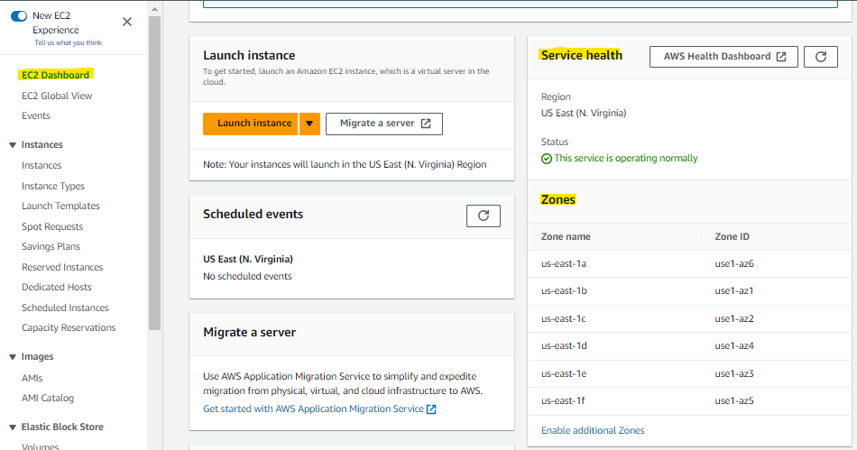

To find your Availability Zones using the AWS CLI
- Use the describe-availability-zones command as follows to describe the Availability Zones within the specified Region that are enabled for your account.
$ aws ec2 describe-availability-zones --region region-name
- Use the describe-availability-zones command as follows to describe the Availability Zones regardless of the opt-in status.
$ aws ec2 describe-availability-zones --all-availability-zones

How VPC helps with Real Time scenarios
What is VPC and how it helps DevOps Engineers?
- Logically Isolated Area

Provides
Logically Isolated Area of AWS Cloud
VPC
Launch AWS Resources
Subnet
EC2

Subnet Subnet

VPC

When talked about Launch AWS Resources, it means with the diagram, VPC is divided into subnets and in the subnets EC2 are hosted.
VPC will have number of IP’s. For example in CIDR 192.168.0.0/16 no of ip’s can be calculated using the last digit after /
Total bits will be 32 and here its 16 are for Host bit and 32-16=16 is going to be your N/W bit.
This N/W bit will help you to get IP’s. i.e, 2^{Network Bit} -2 whatever the value is the no of ip’s subnet will have, ec2 will get one of the IP.

- VPC helps you to control Virtual Network Environment
- You can select IP address range.
- You can create Subnet
- You can configure Route Table and Network Gateways.

Network Gateways?

Network Gateway

NAT Gateway
Internet Gateway
Internet

Internet Gateway helps you connect to internet which enables your infrastructure to connect to internet and it is placed on top of VPC.
IGW
VPC

ec

Whenever you attach the Internet gateway to VPC, whatever the servers we have that will be able to communicate with internet.
IMP: If you are using default vpc, all your setup is done by default like public ip, private ip, Route table configured, Internet Gateway & NAT Gateway configured etc and everything in place.

But whenever you join any organization, you have to create Custom VPC i.e., custom networking where you create your own public subnet, private subnet, VPC, NAT Gateway, subnet association. We shall come up with a topic to build a 3-tier AWS Network and create it as well.
What is Public and Private Subnet?
Public Subnet

Subnet
Public Subnet

General candidates do answer in this way when asked
Public subnet is something, where I keep my application and people from outside will be able to access my application.
Private subnet is something, where I keep my application or database where external users will not be able to access the application.
But as we are DevOps Engineer’s, we cant answer it like the way… Let’s have the overview what it is.
VPC
Public Subnet
Subnet
Private Subnet
Make it Public
Make it Private
Internet Gateway
Route Table
Internet Gateway
Route Table
How to make it public subnet?
A public subnet is a subnet in which/where the Route table is associated with internet gateway.
A private subnet is a subnet in which/where the Route table is not associated with internet gateway.
As told above if internet gateway is put above vpc level app will be accessible over outside/public / internet.
- Attach Internet Gateway at VPC level
- Attach/Associate all the public subnet to Route Table itself. And Route table is attached to internet gateway.
Scenario: In Private Subnet, you place your database, and it has to able to connect to internet, but any external person could not access it, how we can achieve this is by using NAT Gateway. This is required because your database requires some maintenance activities like to patch, upgradations etc, you need internet. You want to go to internet but don’t want internet to come to you, So NAT Gateway comes into picture, we place NAT gateway into public subnet.

Public Subnets
When building multi-tier applications or microservices, some applications and services will likely need to be exposed to incoming traffic from the Internet. However, many of backend processes may only need access the Internet, and not allow inbound traffic. Implementing this type of architecture can be accomplished by having externally exposed services in a “public subnet” and everything else in a “private subnet.”
A public subnet is any subnet that has a route to an Internet Gateway. The allows traffic directed for the Internet to have a path out, and for inbound Internet traffic to be routed to the services in the subnet.
Note: Typically, this route will be a “default” route – that is, one with a destination of “0.0.0.0/0”.
Note: Despite common misunderstanding, having auto-assigned public IP addresses in a subnet does not make a subnet public – though it is common as having a public IP address is needed for inbound Internet traffic.

So what is an Internet Gateway?

Internet Gateway
An Internet Gateway is a VPC component that allows communication between the VPC and the Internet. They are horizontally scaled, redundant, and highly available.
As its name implies, it’s like a router on the edge of a network. Without an Internet Gateway, nothing in a VPC can access the internet, even with a public IP address. There is no charge with Internet Gateways, and it is only possible to one per VPC. Additionally, an account’s default VPC already has one of these.

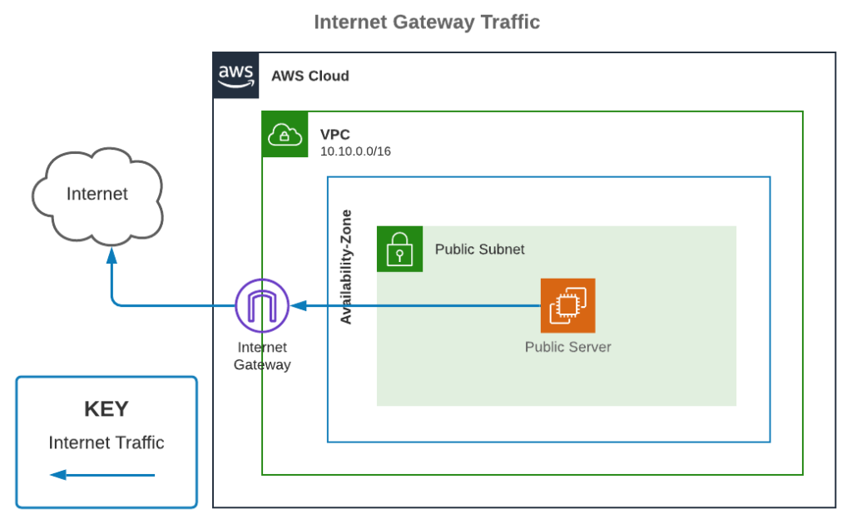

Private Subnets
A private subnet is any subnet that doesn’t have a route to an Internet Gateway (that is, any subnet that is not public). As a result, they have no means to communicate with the Internet. This is where NAT Gateways and Instances come in to play, they allow a private subnet access to the Internet.
We’ll start with NAT Gateway, as it will make understanding NAT Instances easier.

NAT Gateway
A NAT Gateway is an AWS service that allows a private subnet to have access to the Internet, but prevents the Internet from initiating a connection directly to the instances.
While the NAT Gateway is needed for private subnets to have Internet access, it is created in a public subnet. Unfortunately, it has an hourly cost unlike Internet Gateways.
Because they are deployed into a single availability zone, to ensure high availability it is best to deploy one per availability zone and configure routing to use the NAT Gateway in the same availability zone.

To use the NAT Gateway, assign a route in the private subnet, in lieu of a route to an Internet Gateway. Traffic destined for the Internet will flow from the private subnet to the NAT Gateway in the public subnet, and then out to the Internet through the Internet Gateway.
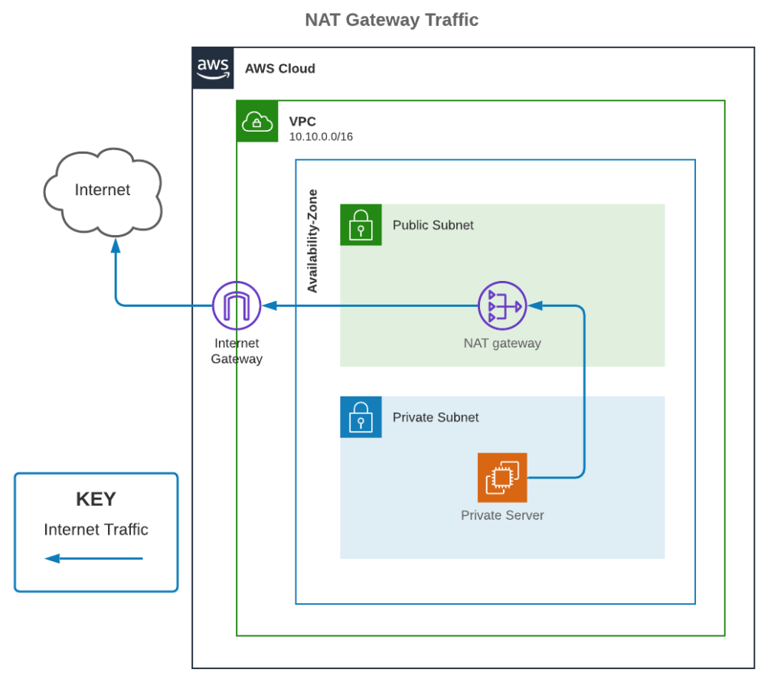

NAT Instance
Unlike NAT Gateway and Internet Gateway, a NAT Instance is not a special service offered by AWS. It is just a term for when using an EC2 instance to perform NAT Gateway-like functionality. It is similar to hosting database software on an EC2 instance rather than using Amazon RDS.
Because it is a self-managed instance, configuring routing, updating the software and operating system, and right-sizing instances is the responsibility of the owner. It is generally not recommended unless there is a specific use-case that needs to support this customization.
Similar to a NAT Gateway, a NAT Instance will need to be in a public subnet, and a private subnet will need a route to the NAT Instance to have internet access.

Putting it together
To help put it all together, here’s the bigger picture connecting all the parts in a common environment.
For a public subnet to have Internet access, inbound and outbound, an account needs:
- Internet Gateway attached to a VPC
- Route to the Internet Gateway in the attached route table
- Instances have public IP addresses (auto-assigned or attached Elastic IP address)
- Appropriate security group and NACL allowances
For a private subnet to have Internet access, the following will provide outbound Internet access but not inbound:
- Internet Gateway attached to a VPC
- NAT Gateway or Instance in a public subnet in the same VPC
- Route to the NAT Gateway or Instance in the private subnet’s attached route table
- Appropriate security group and NACL allowances
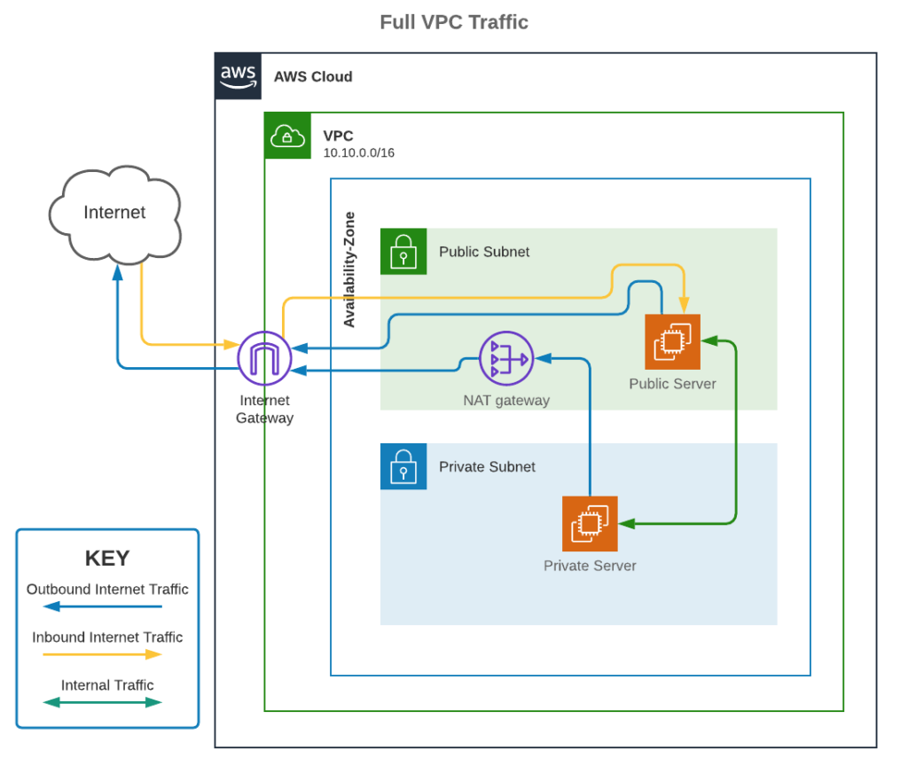
Hopefully this provides a clearer understanding of the differences between the Internet Gateway, NAT Gateway, and NAT Instances on AWS. Additionally, this should have illustrated the difference between public and private subnets, and how to use the private subnet to block external connections to more secure servers and applications.
If you would like to read in greater detail about this topic, here are some links to AWS Docs on the discussed topics.
- Internet Gateways and Private vs Public Subnets: https://docs.aws.amazon.com/vpc/latest/userguide/VPC_Internet_Gateway.html
- EC2 Instance IP Addresses: https://docs.aws.amazon.com/AWSEC2/latest/UserGuide/using-instance-addressing.html
- NAT Gateway and NAT Instance Comparison: https://docs.aws.amazon.com/vpc/latest/userguide/vpc-nat-comparison.html

How Ec2 Become a web Server?
What is EC2 and real time use cases.

EC2 is Elastic Compute Cloud, provides scalable compute capacity.
It helps organizations to deploy applications faster, without investing in hardware upfront.
We can take different kind of machines in EC2
- Compute Optimized --> High computing power
- Learning Optimized --> Machine Learning
- Memory Optimized --> Very high memory
- Network Optimized
You can host Applications and Databases onto your EC2 instances.
Let’s have a lab session on EC2 instance.
PROJECT 01: HOST YOUR FIRST Web Application on EC2?
Host your personal application on AWS EC2 --> This is A of DevOps project to start with DevOps.
- Choose Amazon AMI
Install httpd
AWS EC2
- Create EC2 Instance
Enable / Disable Services
Amazon AMI
- Install httpd / apache2
- Enable/Disable the service
Security groups handling
- Security groups prospective troubleshooting.
Application Accessible
Share Ip to Anyone
- Create ec2 instance
- Name it as Web server
- Use amazon Linux AMI
- Choose t2.micro
- Choose keys existing or else create new
- N/w settings leave as it is
- Click on Launch instance.
Login to EC2 Instance
$ sudo su -
$ yum update -y
$ yum install httpd -y
$ systemctl status httpd
$ mkdir /tmp
$ cd /tmp Got to Free CSS Templates, CSS Layouts & More!
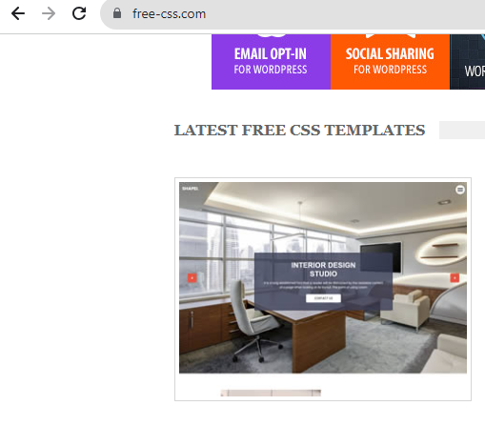
Click on Download
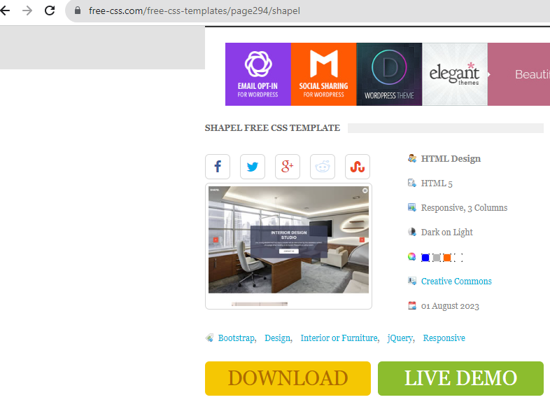
Copy the Link address for download and from ec2 instance download it using wget.
$ pwd
/temp
$ wget https://www.free-css.com/assets/files/free-css-templates/download/page294/shapel.zip
$ ls -lrt
$ unzip shapel.zip
$ ls
$ cd shapel-html
Copy all the files to /var/www/html location.
$ mv * /var/www/html
$ ls -ltr /var/www/html
After copying all the file to the location of httpd/webserver, you have to take the ip and access on browser.
It says, could not load, it because of firewall port 80 in security groups and also the httpd service on EC2.
$ systemctl enable httpd
$ systemctl start httpd
Now you will be able to access the page.
S3 Real-time Use cases & Project
Amazon S3: Object storage built to retrieve any amount of data from anywhere
Scale storage resources to meet fluctuating needs with 99.999999999% (11 9s) of data durability.
Store data across Amazon S3 storage classes to reduce costs without upfront investment or hardware refresh cycles.
Protect your data with unmatched security, compliance, and audit capabilities.
Easily manage data at any scale with robust access controls, flexible replication tools, and
organization-wide visibility.
How it works
Amazon Simple Storage Service (Amazon S3) is an object storage service offering industry-leading scalability, data availability, security, and performance. Customers of all sizes and industries can store and protect any amount of data for virtually any use case, such as data lakes, cloud-native applications, and mobile apps. With cost-effective storage classes and easy-to-use management features, you can optimize costs, organize data, and configure fine-tuned access controls to meet specific business, organizational, and compliance requirements.
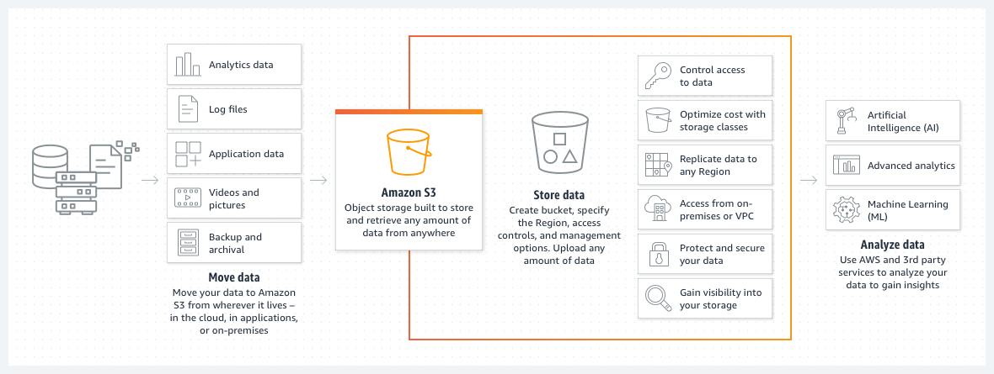

S3 is a simple storage service. Example in real time is related to google drive for the files upload scenario.
S3 provides you secure environment, durability, highly scalable and can store objects. This are the features it enables for developers or IT team.
Size could be 0B to 5TB

Scenario: Create a application which is running on web server, The application wants to retrieve, store and update, delete the data from anywhere. In that case, the application should be able to access, we will create S3 bucket and we focus on implementation of S3 bucket and make integration in such a way that my application should be able to access, retrieve update the data from S3 bucket.

PROJECT 02: Host a static website on s3 bucket & troubleshooting

- Host a static website on AWS S3
- Create S3 bucket
- Allow Public Access
- Upload file to S3 bucket
- Frame it for the application to be accessible anywhere.

- Bucket name: devadevops
- Region: us-east-1
- Object Ownership ACLs enabled.
- Uncheck the Block All Public Access and select the checkbox.
- Click on Create Bucket
- Go to the S3 bucket
Got to Free CSS Templates, CSS Layouts & More!
Click on Download
Copy the Link address for download
- Unzip the downloaded files.
- Go to S3, click on Upload
- Go to Properties, You will find the option Static web hosting
- Click on Edit and Enable it and Save changes.
- Hosting Type -- Host a static website
- Index Document -- index.html
- Error Document :
- Click on Save
- Once Saved you get options like Bucket website endpoint under Static website hosting section.
- You can share that URL with anyone to access the website.
- 403 Forbidden
- Go to S3 bucket, select the objects, under Actions and select Make Public using ACL and click on make public.
- Click on the Bucket website endpoint under Static website hosting section and you should be able to access the website.

IAM Roles and Policies with Real-time scenarios

IAM = identity & Access Management
- Who can access your account, specific components etc can be managed using AWS IAM role.
- Set users, permissions & Roles to grant access to different AWS services.
- Enables organization to create multiple users with own credentials.

Scenario:
I have an EC2 instance where im running an application and this application wants to access to s3 bucket.
There should be some services to help me to connect with s3 bucket from ec2, there comes IAM Roles.
Once you attach an IAM Role to EC2 instance with IAM policy (1. AWS defined 2. Custom Defined) where it has to be define that user can access the S3 bucket and that IAM role you attach to EC2 and the EC2 can connect with S3 bucket.
PROJECT 03: HOW TO ACCESS A S3 BUCKET FROM AN EC2 INSTANCE?

Allow access to EC2 to access S3 Bucket

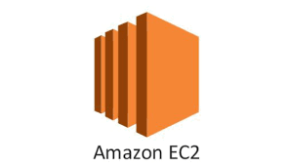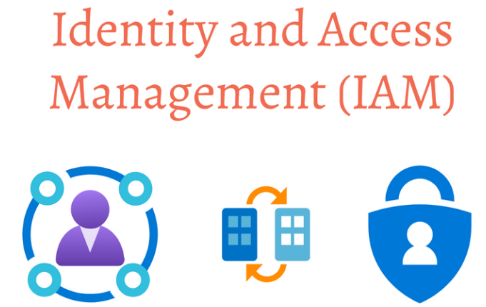

Create EC2 instance
Connect to the server
Install aws cli on server
$ aws s3 ls
$ aws configure
Aws console, search for IAM -> Roles -> Add Roles -> Trusted entity type as AWS Service --> Use case as EC2 --> Next --> Permissions Policies --> Amazon Full S3 bucket access --> Click Save --> Provide name of the role --> Create Role
Select EC2 instance --> Actions --> Security --> Modify IAM Role --> Choose IAM Role --> Update IAM role

$ aws s3 ls
$ aws s3 ls devadevops -- list the files and folders in S3 bucket.

Next Sessions
Various other essential AWS DevOps services like below.
CI/CD
Infrastructure
Security
Monitoring

Day-6
Introduction of Course
Prerequisites
What topics we'll cover today ?
Lets revise Day 05 & Day 06 Topics
Start with Day 07 Introduction
AWS CICD SERVICES & USECASES
What is CODE COMMIT & where to Use ? Real Time use-case with Scenarios
What is CODE BUILD & where to Use ? Real Time use-case with Scenarios
What is CODE DEPLOY & where to Use ? Real Time use-case with Scenarios
What is CODE PIPELINE & where to Use ? Real Time use-case with Scenarios
AWS INFRASTRUCTURE & INFRASTRUCTURE AS A SERVICES
IAAC & AWS INFRASTRUCTURE Mind maps
EC2
What is ECS and EKS ? & where to Use ? Real Time use-case with Scenarios
What is AWS LAMBDA ? & where to Use ? Real Time use-case with Scenarios
How to Create and Manage INFRASTRUCTURE in AWS ? AUTOMATIONS
What is CLOUDFORMATION and where to Use ? Real Time use-case with Scenarios
What is CDK or CLOUD DEVELOPMENT KIT ? WHY it's so popular ? Real Time use-case with Scenarios
Introduction to TERRAFORM !
How to SECURE CLOUD INFRASTRUCTURE ?
MINDMAPS FOR AWS SECURITY SERVICES
What is IAM ROLE & POLICIES and where to Use ? Real Time use-case with Scenarios
What is VPC SECURITY GROUPS ? and where to Use ? Real Time use-case with Scenarios
What is CLOUDTRAIL ? and where to Use ? Real Time use-case with Scenarios
MONITORING SERVICES & MINDMAPS
What is AWS CLOUDWATCH ? and where to Use ? Real Time use-case with Scenarios
What is METRICES ? Real Time use-case with Scenarios
What is AWS ALARM ? and where to Use ? Real Time use-case with Scenarios
What is LOGS ? Real Time use-case with Scenarios
What is AWS CLOUDWATCH DASHBOARDS ? and where to Use ? Real Time use-case with Scenarios

Start with Day 06 Introduction

Learning Path MindMap (Topics of Discussion today)
Learning Path

Monitoring
Security
Infrastructure
CI / CD
Essential Services

Apart from this tools, we will going to see project implementation with each tool.

AWS CICD SERVICES & USECASES

What is CODE COMMIT & where to Use ? Real Time use-case with Scenarios
What is CODE BUILD & where to Use ? Real Time use-case with Scenarios
What is CODE DEPLOY & where to Use ? Real Time use-case with Scenarios
What is CODE PIPELINE & where to Use ? Real Time use-case with Scenarios
AWS INFRASTRUCTURE & INFRASTRUCTURE AS A SERVICES
IAAC & AWS INFRASTRUCTURE Mind maps
EC2
What is ECS and EKS ? & where to Use ? Real Time use-case with Scenarios
What is AWS LAMBDA ? & where to Use ? Real Time use-case with Scenarios
How to Create and Manage INFRASTRUCTURE in AWS ? AUTOMATIONS
What is CLOUDFORMATION and where to Use ? Real Time use-case with Scenarios
What is CDK or CLOUD DEVELOPMENT KIT ? WHY it's so popular ? Real Time use-case with Scenarios
Introduction to TERRAFORM !
How to SECURE CLOUD INFRASTRUCTURE ?
MINDMAPS FOR AWS SECURITY SERVICES
What is IAM ROLE & POLICIES and where to Use ? Real Time use-case with Scenarios
What is VPC SECURITY GROUPS ? and where to Use ? Real Time use-case with Scenarios
What is CLOUDTRAIL ? and where to Use ? Real Time use-case with Scenarios
MONITORING SERVICES & MINDMAPS
What is AWS CLOUDWATCH ? and where to Use ? Real Time use-case with Scenarios
What is METRICES ? Real Time use-case with Scenarios
What is AWS ALARM ? and where to Use ? Real Time use-case with Scenarios
What is LOGS ? Real Time use-case with Scenarios
What is AWS CLOUDWATCH DASHBOARDS ? and where to Use ? Real Time use-case with Scenarios

